ADDENDUM #1
FOR
RFP – Lift Rental and Maintenance Services
Clarifications:
The Mandatory Pre-Proposal meeting for this work will be held virtually on March 8, 2023 at 1:00 PM. Please follow the Teams Meeting link provided below.
RFP due dates are as follows:
Meeting Link for Mandatory Pre-proposal (Click Here)
Site Visit: March 9, 2023 at 10 AM, confirm attendance with Janet Mitrocsak after the Pre-Proposal meeting
Questions Due: Wednesday, March 22, 2023 by 12 PM
Proposals Due: Wednesday, April 5, 2023 by 1 PM
An attendance sheet from the meeting will be posted as an addendum afterwards.
Instructions for Registering under our Cobblestone Vendor Portal for the Project as an Interested Respondent are below.
Please note, this website works best with Google Chrome or Microsoft Edge browsers. Other browsers may have technical difficulties. Please contact Lisa Dobbertin if you have any issues registering (ldobbertin@paconvention.com, 215-418-4769).
https://paconvention.cobblestone.software/gateway/SolicitationPublicSearch.aspx
- Your company must first register for our Vendor Portal if you have not done so already. Instructions for this are located under “Vendor Portal User Guide” here:
- Once registered on the Vendor Portal, you can then Register as an Interested Respondent for the Project.
  - Login with your User Name, Password, and Company ID
  - Select “Search All Solicitations” under the Solicitation menu
  - Hit “View” under the Solicitation Project you want to Register for
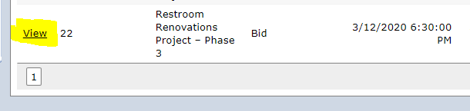
  - Under the Page Actions Menu on the left, click the button that says “Register as Respondent”
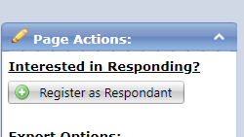
  - Once you see this message, you are then registered.
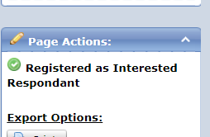
  - Lastly, please make sure your email is set up so that future Cobblestone messages do not get sent to your Spam folder.

